ENGRI 1170 Introduction to Mechanical Engineering
Cornell University, Fall 2008

Motor Characteristics Lab

In PBL 1, you have become familiar with torque, rotational motion, and gears for an engine/car. In the current lab, you will measure the torque vs. RPM performance of a small electric motor connected to a gearbox. You will also determine how closely the gearbox behavior follows ideal behavior, and how closely the motor’s performance agrees with its specifications. The MIG 280 DC motor is a small electric motor that will be used in the final project of the course. Characterizing the motor will help in the design of the final project.

Unlike that of a combustion engine, a DC electric motor’s torque decreases linearly with motor RPM. The motor’s characteristics are described by a “stall torque” (the value of torque at zero RPM) and a no-load RPM (the value of motor rotational speed at zero torque). These two quantities are the intercepts of the motor’s ideal torque curve.

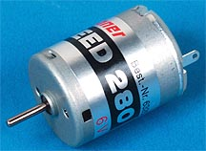
You will be provided with a motor connected to a gearbox, along with a set of weights, a meter stick, a stopwatch, and a tachometer. (The tachometer measures the RPMs of the output shaft of the gearbox.) These items are arranged so that the output of the gearbox drives a cylindrical shaft that rotates to lift the weight. Measurements of the rate at which a weight is lifted will allow you to calculate the power for different weights and gear ratios. The gearbox output RPM for each condition can be found from either the tachometer reading or the speed at which the fishing line is wound around the shaft. You should find it both ways and compare, when possible; under some conditions the velocity will be so high that the tachometer will be the only option. From the above, you need to generate certain curves and answer the following questions.

CURVES

- Measured power vs. RPM for each gear using (a) tachometer (where possible) and (b) fishing line velocity (where possible)
- Measured torque vs. RPM for each gear using (a) tachometer (where possible) and (b) fishing line velocity (where possible)

Notes: 1) and 2) apply to the output of the gearbox. You will not be able to cover the entire operating range of the motor with a single gear.

- Motor torque and power vs. RPM (@ input of gearbox) inferred from each set of the above data.
- Ideal torque and power curves obtained from the motor’s stall torque and no-load RPM, (from specifications).

QUESTIONS

- How well do readings obtained with the tachometer and fishing line velocities agree with each other?
- How consistent are the motor torque vs. RPM data sets obtained with different gears?
- How do the ideal torque and power curves compare to the experimental motor torque and power vs. RPM curves?
- Discuss possible sources of error in the experiment, and their impact on your measurements and conclusions.

Note: For 1) through 3), be quantitative, and provide possible reasons for any differences.

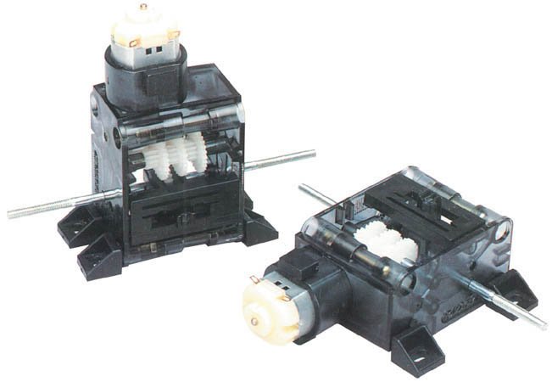

IMPORTANT INFORMATION

➢ MIG 280 DC electric motor – “Manufacturer’s” Specifications:

@ 6.00 V (max rated)
- No-load RPM: 14,000 RPM
- Max Power: 5.00 Watts
- Stalled torque: 1.364 x 10⁻² N-m
@ 5.25 V (lab set-up)
- No-load RPM: 12,250 RPM
- Max Power: 4.375 Watts
- Stalled torque: 1.364 x 10⁻² N-m

➢ Gearbox Specifications: (see gear selector on gearbox for gear positions)

Gear Ratios: Position #2 – 17.68:1
Position #4 – 119.52:1
Position #6 – 807.93:1

Gearbox Output Shaft Diameter: 1.00 cm

LAB PROCEDURE

- Testing Procedure (hand measurements = using fishing line velocity):
  - With the bucket at the bottom of the pre-measured length, load with desired weight
  - Ensure that the line is taut and that the weight is fully supported by the rig.
  - While one person watches the meter stick and the marked off distances, the other will operate the power switch for the motor.
    - Turn on the motor.
    - Start the stopwatch when the bucket passes the first mark. (Pick one point on the bucket, and use this as the reference point, the top or bottom will work well.)
    - Stop the stopwatch when your reference point on the bucket passes the second mark.
    - Stop the motor before the bucket reaches the pulley.
    - Calculate power and RPM. (You need to figure out exactly how to do this; use consistent units)
    - Hold on to the weight and disengage the gearbox by sliding the gearbox switch slightly to the side, slowly lower the bucket and re-engage the gears by moving the switch back to the original position (you may need to slowly turn the spool by hand in order to re-engage the gears).
    - Repeat procedures a-d, adding one increment of weight at a time, until you have enough points to graph a power curve. Do NOT test the holding torque (motor stall point) as this will burn out the motor.
- Move to a test rig with a different gearing ratio (or change the gearing ratio on your gearbox) and repeat procedures a-d, create a power curve for each gear ratio.
- Testing Procedure (tachometer measurements):
  - With the lower gear ratios, you may find it necessary to use the tachometer (optical detector) and oscilloscope to accurately compute power. The testing procedure is similar.
  - With three people per group, both methods of measurement (hand and oscilloscope) can be used. With two people, you will have to repeat the test with both methods.
  - While one person operates the motor, the other will watch the oscilloscope and press “Run/Stop” to hold data on the screen at the appropriate moment.
    - Set up the weights as detailed in the hand measurement section.
    - Turn on the power supply and oscilloscope. Ensure that the red light from the detector illuminates the wheel with reflective tape. Ensure that the power supply voltage setting is between 4-8V. Check and make sure that the oscilloscope shows a voltage reading equivalent to the power supply voltage setting.
    - Turn on the motor.
    - You will observe a step pulse function as the weight ascends. Wait until the first few pulses have passed and then hit the “Run/Stop” button to hold the information on the screen. If you have selected a poor time scale, adjust as necessary for accurate measurement (you want 2-3 boxes per pulse), and repeat the procedure.
    - Calculate the frequency of the pulses by measuring from the front of one pulse to another, (frequency = # of pulses in your measurement / amount of time in your measurement). Time is found by multiplying the number of boxes between pulses by your selected time scale (can be read from the bottom of the oscilloscope screen).
    - Record the frequency on your data sheet, along with the applied weight.
    - Calculate power using your hand measurement and the oscilloscope measurement. These measurements will probably not be the same.
    - Reset the motor and weight, press “Run/Stop” on the oscilloscope, adjust the time scale (if necessary), and repeat the procedure until you have enough points to read the power curve.
  - NOTE: You will need to be relatively fast with both the oscilloscope and the motor when testing the higher RPM, lower gear ratio settings. It may take a few tries to get it right. The quicker your reflexes, the better!

