ENGRI 1170, Introduction to Mechanical Engineering
Cornell University, Fall 2008

Tensile Test Lab

Summary: You will be using a materials testing machine (also called a universal tester), to measure the stress-strain relationship in several materials. The materials you will be testing are:
    - Steel, 1018
    - Aluminum, 6061
    - Brass, 360 free machining
    - PVC, Type 1

Using the recorded stress-strain data, you will plot and examine their stress-strain curves to determine various mechanical properties of each material.

Testing: Testing will be done according to ASTM (American Society for Testing Materials) standards for materials and testing. These standards set requirements for the type of specimen used, procedures, and analysis of results. Specimen, procedures and instructions for analysis of results will be provided for you, so it is not necessary for you to know the ASTM Standard for the test.

Specimens. We will be using a standard flat “dog bone” specimen for our test. The specimen are called ‘dogbones’ because of their shape. The middle portion (gage) is reduced in width, so that rupture will occur near the center of this ‘gage length’.

Procedure: Your TA will go over how to use the machine in the lab and run a test during class. Some important thing to consider when testing are: the alignment of specimen in the testing machine and observing how the material deforms and fails (for instance when testing low carbon steel one can observe the lateral contraction as the specimen is stretched beyond yield limit, and the ‘necking’ - a pronounced reduction of the cross-section just prior fracture).

Specimen Preparation: To prepare your specimen for testing, some initial measurements and markings need to be made. You should measure all the dimensional characteristics of your specimen. Of critical importance are the cross sectional area in the reduced section.

You also need to mark a center line down the middle of the specimen. These marks will be used to align the specimen in the testing machine. You should also measure and mark the gage section (2”) so that you can observe how much the specimen has deformed at the end of the test.

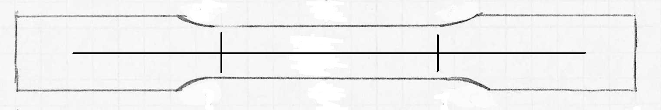
Mark center line
Mark gage length lines
Results: You will get a data file for each material tested. Plots of the data will show the load vs. displacement data from the test. You will need to convert this data into stress-strain curves, by using the appropriate formulas. The data should also be zeroed using the initial displacement and load values.

From the stress-strain diagram and the measurements you took before the test, determine:

the elastic and plastic regions of the curve
elastic modulus
proportional limit
yield strength
ultimate strength

Report: Each report should include a brief description of test procedure, copies of stress-strain diagrams, tabular results, and an interpretation of results by answering the questions below. Also include equations used to make calculations in results table.

Questions:

- Explain why the shape of the specimen (dog bone) is important to the tensile test.
- Why is the stress vs. strain curve plotted instead of the force vs. length change?
- Compare the ductility/brittleness of the different materials by discussing their stress-strain graphs.
- Do the values for elastic modulus calculated in the tensile test match up with (a) the value calculated in the bending lab? (b) the values given in Wickert, when available. If not, why not?

Definitions:
Stress-strain curve: an x-y plot of stress vs. strain through the entire range of loading of the specimen until failure. In our case this is derived from the load vs. displacement data obtained from the testing machine. We will use engineering stress and engineering strain.
Engineering stress: load (force) per unit area; the normal (axial) stress is determined by dividing the load by the original (pre-deformation) cross-sectional area of the specimen.
Engineering strain: the unit deformation of the material under load. It is defined as the ratio of change in length to the initial length. Strain has no units and is a dimensionless quantity.
Yield strength: the stress at which the material begins to “yield”. For steel and most metals, a 0.2% offset method is used to define the yield stress. A strain value of 0.002 is selected and a line parallel to the elastic portion of the stress-strain curve is constructed. The intersection of this line with the stress-strain curve defines the value of the yield stress. See pages 138-139 of text.
Ultimate (tensile) strength: The maximum (engineering) stress on the specimen – Load_max divided by original cross-sectional area of specimen.
Modulus of elasticity: Slope of the linear portion of the stress-strain curve – change in stress divided by change in strain.
Proportional limit: Stress at which linear stress-strain relationship ceases.

Ductile: Easily stretched or molded without breaking – not brittle.
Brittle: Easily broken, snapped or cracked when subjected to stress.
See pp. 135-136 of text for more details.

